D2ACH2103 (3 Pages) Name..............................
Reg.No...........................

SECOND SEMESTER M.Sc. DEGREE EXAMINATION, APRIL 2022
(Regular/Improvement/Supplementary)

CHEMISTRY
FCHE2C07: REACTION MECHANISM IN ORGANIC CHEMISTRY

Time: 3 Hours Maximum Weightage: 30

Section A: Short answer questions. Answer any eight questions. Each carries 1 weightage.
- Predict the expected product of the reaction and suggest the mechanism by which the product formed.
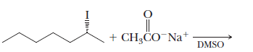
- Show how will you convert 1-chloroethane into 3-hexyne by nucleophilic substitution reaction.
- Write an example involving S_{E}i mechanism.
- Identify A and B in the following reaction.
- Write an example for the formation and a reaction involving nitrene intermediate.
- Explain in brief about the structure of nitrene?
- Give the structure of the cationic intermediates that are formed in the following reactions.
- What is Reformatsky reaction?
- Write the tandem steps involved in the conversion of α-diazocarbonyl into a ketene.
- Predict the product and write the important steps involved in reaction.
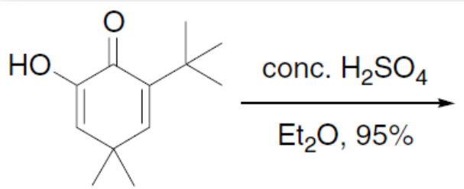
(P.T.O.)

- Write the reaction involving the conversion of 2-chlorocyclohexanone into methyl cyclopentane carboxylate.
- Write a short note on Sommelet-Hauser Rearrangement.
(8 × 1 = 8 weightage)

Section B: Short essay questions. Answer any four questions. Each carries 3 weightage.

- Discuss the factors affecting the competition of S_{N}2 reaction and E2 elimination by citing suitable example.
- Identify the products of the reaction. Justify your answer.
- Discuss the formation and stability of classical and non-classical carbocation.
- Identify A and B in the reaction and write the mechanism.
- What conditions are required for allylic halogenation to be occurred? Why does this reaction outcompete addition when these conditions are met? Justify your answer by citing an example.
- Write the product of the following reaction and suggest a mechanism.
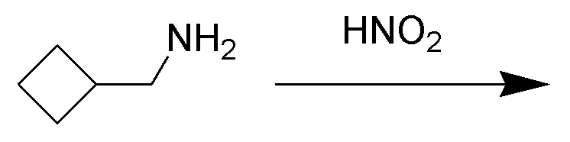
- How would you convert Camphenilol to Santene?

(4 × 3 = 12 weightage)
Section C: Essay questions. Answer any two questions. Each carries 5 weightage.

- (a) Discuss the mechanistic and stereochemical aspects of reactions of enantiomers of 1,2-Dibromo-1,2-diphenylethane with sodium ethoxide.
(b) Write the mechanism of E1cB elimination.

- Write the mechanism of:
(a) Claisen condensation, (b) Perkin reaction, (c) Stobbe condensation and (d) Knoevenagel condensation.

- (a) Write a brief note on Hoffmann‐Loeffler-Freytag reactions.
(b) Discuss McMurry Coupling.
(c) Predict the product of the reaction of triplet carbene with E-stilbene.
(d) Write the structure of the intermediates and product formed in the reaction.

- Discuss the following rearrangements occurred at electron deficient nitrogen.
(a) Hofmann (b) Curtius (c) Lossen (d) Schmidt and (e) Beckmann.
(2 × 5 = 10 weightage)

